Bart Quaink - 11121424

*How bottom up processing of visual information is influenced by top down processing*

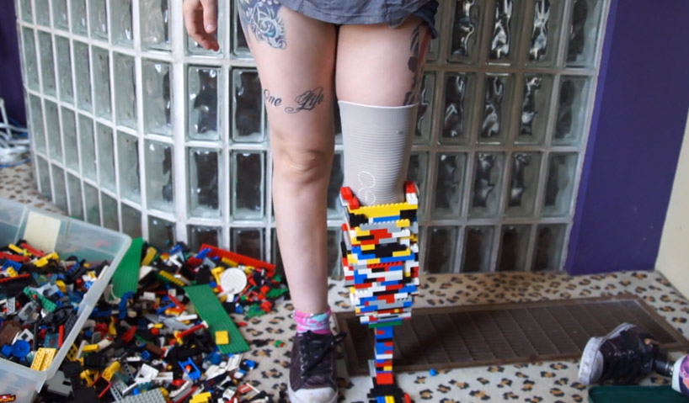

Look at this image. We see the building blocks on the left, Lego blocks that can be used to build basically anything you want, if you have the imagination for it. And then the final wanted product on the right. Is this the right way to build? Was this the intended way for the Lego blocks to be assimilated or were they actually part of a set intended to be built into a car, fire station or maybe even a spaceship from dimension c137? With this example I want to explain the differences between bottom up processing, the separate Lego blocks, and top down processing, the prosthetic leg.

Like I said, the Lego blocks is the bottom up process of visualizing information to the brain. All the different pieces have different colours, were intended to use on different ways where different final products, or objects would be created by. The first step in bottom up processing is seeing and observing the different pieces. After that your brain is creating different patterns, connecting the pieces together, maybe by colour, maybe by size, who knows? This basic info then is converted to visual objects, perhaps what the creator’s intended object was.

But not in this case, there is a reason this woman decided not put the pieces back together like intended but instead created something completely different. Something *she* actually wanted to create. This means she had an object set in her mind already that she wanted to create. So even though she saw all the pieces, could see different connections and patterns between them, she already knew what she wanted to make. This is called top down processing. Due to this top down processing she already had an object in mind. This influenced her bottom up processing to create something else what the blocks were not actually intended for. Of course, one of the beautiful parts about Lego is that one of the intentions is to be able to create anything you wanted, but let’s set that aside for a moment to make this clarification a bit clearer.

So this woman basically used the building blocks, the basis info on a wrong way. She didn’t use the Lego blocks in the intended way so she made a wrong reality from which the Lego blocks should’ve actually been used for. She did saw the information, the Lego blocks, but due to her top down processing influencing the bottom up process, she interpreted the reality ‘wrong’. Instead she created her own reality, the prosthetic leg.